Objectives

* Understand the concept of Universal Gates (NAND & NOR)
* Implement the basic logic gates using universal gates
* Implement boolean functions using universal gates
* Understand gate level minimization

Theory

**Universal Gates:**

A universal gate is a gate which can implement any Boolean function without need to use any other gate type. NAND and NOR gates are universal gates. These two gates can build all the basic gates: AND, OR, NOR, NOT, XOR & XNOR. In practice, this is advantageous since NAND and NOR gates are economical and easier to fabricate and are the basic gates used in all IC digital logic families. Using NAND and NOR gates and De Morgan's Theorems different basic gates & EX-OR gates are realized. NAND gate is the AND gate connected to the inverter. Also, the NOR gate is the OR gate connected to the inverter.

**Figure C1** shows the implementation of NOT, AND & OR gates using only NAND gates

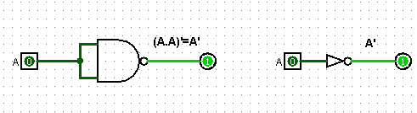

*Fig: Implementation of NOT gate using NAND gate*

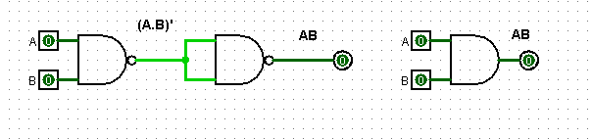

*Fig: Implementation of AND gate using NAND gate*

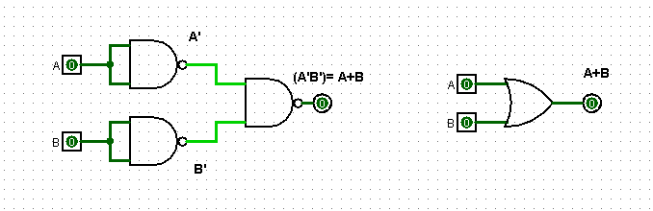

*Fig: Implementation of OR gate using NAND gate*

***Figure C1****: NAND as a universal gate*

Equipment List

* Trainer Board
* IC 7400 Quadruple 2-input NAND gates
* IC 7402 Quadruple 2-input NOR gates

Circuit Diagram

*Figure F1: Implementation of XOR and XNOR using NAND gates*

*Figure F2: Implementation of NOT, AND, OR, XOR and XNOR using NOR gates*

Data & Table

|  |  |  |  |  |  |
| --- | --- | --- | --- | --- | --- |
| **A** | **B** | **C** | **I1=AC** | **I2=BC’** | **F= I1 + I2** |
| 0 | 0 | 0 | 0 | 0 | 0 |
| 0 | 0 | 1 | 0 | 0 | 0 |
| 0 | 1 | 0 | 0 | 1 | 1 |
| 0 | 1 | 1 | 0 | 0 | 0 |
| 1 | 0 | 0 | 0 | 0 | 0 |
| 1 | 0 | 1 | 1 | 0 | 1 |
| 1 | 1 | 0 | 0 | 1 | 1 |
| 1 | 1 | 1 | 1 | 0 | 1 |

*Table F1: Truth table of combinational circuit in Figure B2*

Result Analysis and Discussion

The title of the experiment for LAB02 was “Universal Gates”. In this experiment our goal of the experiment is to understand the concepts of universal gates which are NAND and NOR gates. I learned about Universal logic gates and Boolean function implement and also learned about how to implement all the logic gates using Universal logic gates. In this experiment, had to build a combinational circuit and replaced each of the gates with its NAND gate equivalent. I analyzed the circuit I built in Logisim and found that it matches the truth table of the Lab Manual. It shows that the circuit I designed in Logisim is correctly implanted. I have simulated logic diagrams of the implementations of the gates using Logisim. Implementation of Boolean functions using Universal gates- NAND and NOR. I have learned the gate level minimization and constructed the logic diagram using Logisim smoothly. We did another experiment which was Lab01 experiment number 03. The experiment was an implementation of Boolean function. Here I simulate the circuit of the Boolean Equation F = A’C+AB’+BC and complete the truth table of that equation and stored the data in the truth table. Through this experiment we saw that the theoretical and practical outputs in the truth table was same. Also, I was asked to design the IC diagram for the circuit and I checked the truth table with our previous one. That two was same. So, the circuit works properly.